**Project Based Learning-II**

(Guidelines and Work Book) **Course Code: 210258**

**(2019 Course)**

# Second Year Engineering

Year 2020- 2021

Group ID: 05

Team Members: 1. Siddhant Shendge

1. Shubham Kambale
2. Hetvi Patel
3. Pranjal Chaudhari
4. Shriya Pathak

Project Title: Contactless doorbell and doorlock System.

Name of Mentor: Mrs. Chaitali Shewale

## A PRELIMINARY REPORT ON

### CONTACTLESS DOORLBELL AND DOORLOCK SYSTEM

SUBMITTED TO THE SAVITRIBAI PHULE PUNE UNIVERSITY, PUNE

IN THE PARTIAL FULFILLMENT OF THE REQUIREMENTS

FOR THE ACADEMIC

OF

## SECOND YEAR OF ARTIFICIAL INTELLIGENCE AND DATA SCIENCE

**SUBMITTED BY**

**SIDDHANT SHENDGE ROLL NO.21102**

**SHUBHAM KAMBALE ROLL NO.21112**

**HETVI PATEL ROLL NO. 21142**

**PRANJAL CHAUDHARI ROLL NO. 21147**

**SHRIYA PATHAK ROLL NO. 21161**



**DEPARTMENT OF ARTIFICIAL INTELLIGENCE AND DATA SCIENCE**

**DR. D.Y.PATIL INSTITUTE OF ENGINEERING, MANAGEMENT & RESEARCH**

**AKURDI, PUNE 411044**

**SAVITRIBAI PHULE PUNE UNIVERSITY**

2020 -2021



## CERTIFICATE

This is to certify that the project report entitles

Submitted by

**SIDDHANT SHENDGE ROLL NO.21102**

**SHUBHAM KAMBALE ROLL NO.21112**

**HETVI PATEL ROLL NO. 21142**

**PRANJAL CHAUDHARI ROLL NO. 21147**

**SHRIYA PATHAK ROLL NO. 21161**

is a bonafide student of this institute and the work has been carried out by them under the supervision of Prof. Chaitali Shewale and it is approved for the partial fulfillment of the requirement of Savitribai Phule Pune University, for the award of the second year degree of Computer Engineering.

**Asst. Prof. Chaitali Shewale** **Asst.** **Prof**. **Suvarna Patil**

Guide Head,

Department of AI&DS Department of AI&DS

Place : Pune

Date : 19-05-2022

## ACKNOWLEDGEMENT

First and foremost, we would like to thank to our guide of this project, **Asst.** **Prof. Chaitali Shewale** for the valuable guidance and advice. She inspired us greatly to work in this project. Her willingness to motivate us contributed tremendously to our project. We also would like to thank her for showing us some example that related to the topic of our project.

Apart from our efforts, the success of any project depends largely on the encouragement and guidelines of many others. So, we take this opportunity to express our gratitude to **Asst.** **Prof. Suvarna Patil**, Head of Department of Computer Engineering, Dr. D. Y. Patil Institute of Engineering, Management and Research, Akurdi who have been instrumental in the successful completion of this project.

The guidance and support received from all the members who contributed and who are contributing to this project, was vital for the success of the project. I am grateful for their constant support and help.

**SIDDHANT SHENDGE**

**SHUBHAM KAMBALE**

**HETVI PATEL**

**PRANJAL CHAUDHARI**

**SHRIYA PATHAK**

(S. E. AI&DS.)

## CERTIFICATE

This is to certify that Mr. _ Siddhant Shendge , Shubham Kambale , Hetvi Patel , Pranjal Chaudhari , Shriya Pathak Group No. _____A8______ Division ____A ___Branch____ AI&DS _____ has successfully completed the work associated with **Project Based Learning II (210258**) titled as Contactless doorlbell and doorlock system and has submitted the work book associated under my supervision, in the partial fulfillment of Second Year Bachelor of Engineering(Choice Based Credit System) (2019 course) of Savitribai Phule Pune University.

Date: 19-05-2022

Place: Pune

Guide Head Principal

Mrs.Chaitali Shewale Mrs. Suvarna Patil Mrs.A.V.Patil.

### Table of Contents

|  |  |  |
| --- | --- | --- |
| **Sr.**  **No.** | **Description** | **Page No.** |
|  | Preamble | i |
| 1. | Project Based Learning Syllabus | 1 |
| 2. | Recommended Guidelines and Phases | 3 |
| 3. | Evaluation and Continuous Assessment Sheet | 4 |
| 4. | Project Information Sheet | 5 |
| 5. | Assessment Remarks Sheet | 6 |
| 6. | Project Monitoring ( 1 sheet per week ) | 8 onwards |

**ABSTRACT**

Doorbells are usual signaling devices used to alert the person inside the building to open the door as someone has arrived. Classic doorbells can be seen in every house now a days, which uses simple button and when that button is pressed the bell rings. The doorbell which we are going to make is different from that. We will make a doorbell which is automatic, i.e. it will detect someone in front of it and then it will ring. We will be using a very simple circuit to implement this project. This project can be really beneficial because it’s not always the case that a person can reach the doorbell, so it would be nice if it rings automatically after detecting the person. Also, there is a flexibility that you can adjust the distance according to you by doing some changes in the code you are using to drive the doorbell.We will be using ultrasonic sensor to detect the person and then give the alert using a buzzer. As we know that ultrasonic sensors are used for distance measurement without physical contact for small distances. So it’s the best thing to use ultrasonic sensor for detecting object

**Keywords: IOT, Security.**

**INDEX**

|  |  |  |
| --- | --- | --- |
| **Sr. No.** | **Content** | **Page No.** |
| 1 | INTRODUCTION | 11 |
|  | 1.1 Introduction | 11 |
|  | 1.2 Problem Statement | 12 |
|  | 1.3 Objectives | 12 |
|  | 1.4 Scope of project work | 12 |
| 2 | LITERATURE REVIEW |  |
| 3 | EXPERIMENTAL STUDY | 14 |
|  | 3.1 Introduction | 14 |
|  | 3.2 Methods / Design / Mechanism | 15 |
|  | 3.2.1 Experimental Figure | 16 |
|  | 3.3 Modules The application implementation consists of four modules | 17 |
| 4 | METHODOLOGY |  |
| 5 | ADVANTAGES AND APLLICATION |  |
| 6 | REFERENCES & BIBLIOGRAPHY | 25 |
| 7 | CONCLUSION |  |
|  |  |  |

**LIST OF FIGURES ( If Any)**

|  |  |  |
| --- | --- | --- |
| **Sr. No** | **Title** | **Page**  **No.** |
| I. | FIGURE 1 | 11 |
| II. | FIGURE 2 | 17 |

### CHAPTER 01: INTRODUCTION

#### 1.1 INTRODUCTION

We live in the 21st century where everything is preferred to be fast contactless and automated. COVID has even more increased the need for contactless systems. Well here we propose a contactless doorbell as well as safety system using IOT for automatic visitor recognition and alerting home owner. The value of being able to remotely secure, unlock and open doors has been growing steadily, but there have been a few important inflexion points where the relevance and value has increased.

For decades, remote control of access and entry has been required in various settings, from government, security and industrial facilities, where access needs to be closely guarded and authorised in a secure manner. However, as technology has evolved, so has the accessibility of these technologies.

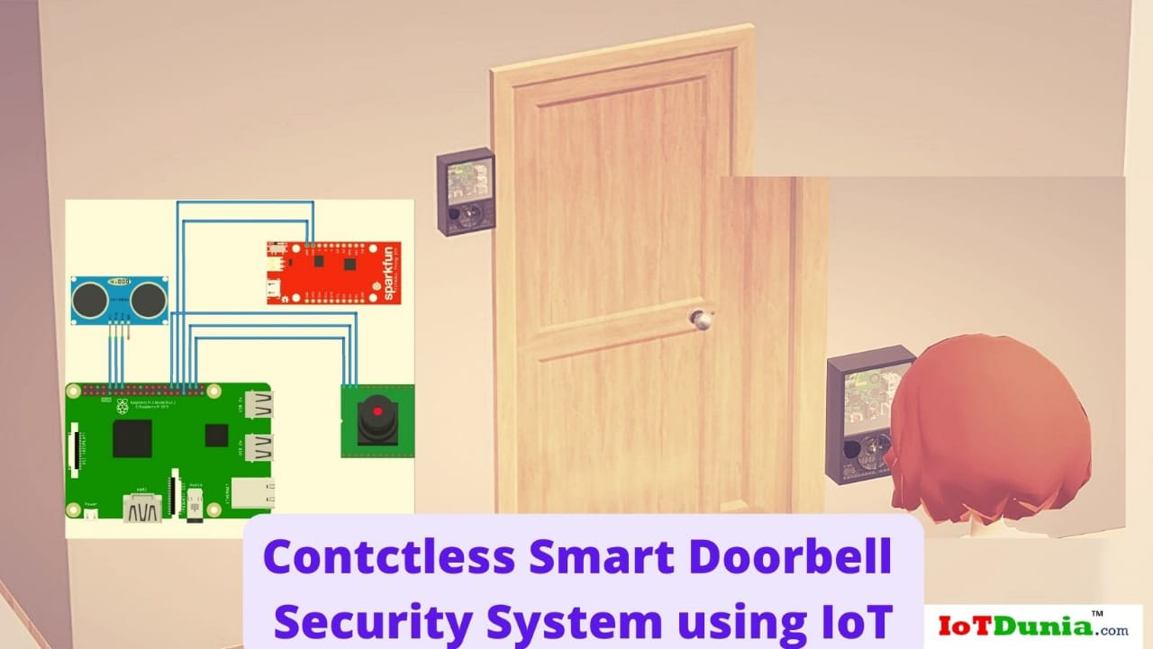Figure 1

**1.2 PROBLEM STATEMENT**

To develop a touchless doorbell system with sensor based technology for the advanced security purpose and reduce the contagious diseases like Covid-19.

#### 1.3 OBJECTIVES

Value of being able to remotely secure, unlock and open doors has been growing steadily.

The goals of this project were to build modern easy to use smart doorlock that allows for accessible unlocking and adds convenience utility and security to your home

##### 1.4 SCOPE OF PROJECT WORK

* The designed Touchless Doorbell is detecting a person who is visiting a home without touch
* To set variable distance user can adjust is by its own. In general, we have sated the distance of person detection as 10 cm.
* we have tested for 10-12 distances in the described range and the result was as per expectations.
* This product functions automatically when a person comes in range of the sensor of touchless doorbell.
* We also had taken care that the product should be economically affordable. We can place it anywhere we want and also the installation is pretty simple.
* The setup of wireless doorbell doesn’t require any internal wiring

**CHAPTER 02 : Literature review :**

## Literature review

**Research paper on Contactless doorbell and doorlock system.**

**Paper number 1:**

# Contactless doorbell and doorlock system

|  |  |
| --- | --- |
| **Name of paper** | **Contactless Doorbell and doorlock system** |
| **Abstract:** | Doorbells are usual signaling devices used to alert the person inside the building to open the door as someone has arrived. Classic doorbells can be seen in every house now a days, which uses simple button and when that button is pressed the bell rings. The doorbell which we are going to make is different from that. We will make a doorbell which is automatic, i.e. it will detect someone in front of it and then it will ring. We will be using a very simple circuit to implement this project. |
| **Authors:** | OA Simon  Bradley Quadros  Ronit Kadam  Wen Shen |

**Paper 2**

|  |  |
| --- | --- |
| **Name of paper** | **A research agenda for security and survialliance.** |
| **Abstract :** | This project can be really beneficial because it’s not always the case that a person can reach the doorbell, so it would be nice if it rings automatically after detecting the person. Also, there is a flexibility that you can adjust the distance according to you by doing some changes in the code you are using to drive the doorbell.We will be using ultrasonic sensor to detect the person and then give the alert using a buzzer. As we know that ultrasonic sensors are used for distance measurement without physical contact for small distances. So it’s the best thing to use ultrasonic sensor for detecting object |
| **Conclusion:** | This project is to bring more next level of enhancement in the security system |
| **References:** | R.J. Robles, T-H Kim, D.Cook, “Review on Security in smart home development”, international journal of advanced science and technology, vol.15,2010. |
| **Authors:** | OA Simon  Bradley Quadros  Ronit Kadam  Wen Shen |

. **CHAPTER 3 : EXPERIMENT STUDY**

**3.1 Introduction**

Doorbells have been playing an important role in protecting the security of modern homes since they were invented. A doorbell allows visitors to announce their presence and request entry into a building as well as enables the occupant to verity the identity of the guests to help prevent home robbery invasion at a moment’s notice. There are two types of doorbells depending on the requirement of wall wiring: the wired doorbells and the wireless doorbells. The former requires a wire to connect both the front door button and the back door button to a transformer, while the latter transfer the signal wirelessly using telephone technology. Modern buildings are typically equipped with wireless doorbell systems that employ radio technology to signal doorbells and answer the doors remotely. Although these doorbells are much more convenient than wired ones, they do not always satisfy the demands of modern homes for the following three reasons. First, the answering machines are normally located at a fixed place (often near to the door), if a occupant wants to answer the doorbell, he/she has to go to the answering machines. Second, if the occupant would like to see the visitors outside, he/she has to go to door. Third, the occupant has no way to answer or admit guests when he/she is not at home,

nor to keep a record of guests.

### 3.2 Method

Whenever a person arrives at our home, so instead of pressing the bell, the person can raise hand at a distance of around 10cm so that the ultrasonic sensor can sense the presence a person and bell will ring automatically using servo motor without any touch to the bell.The plus point of the solution is that the solution can be applied to our existing doorbells..

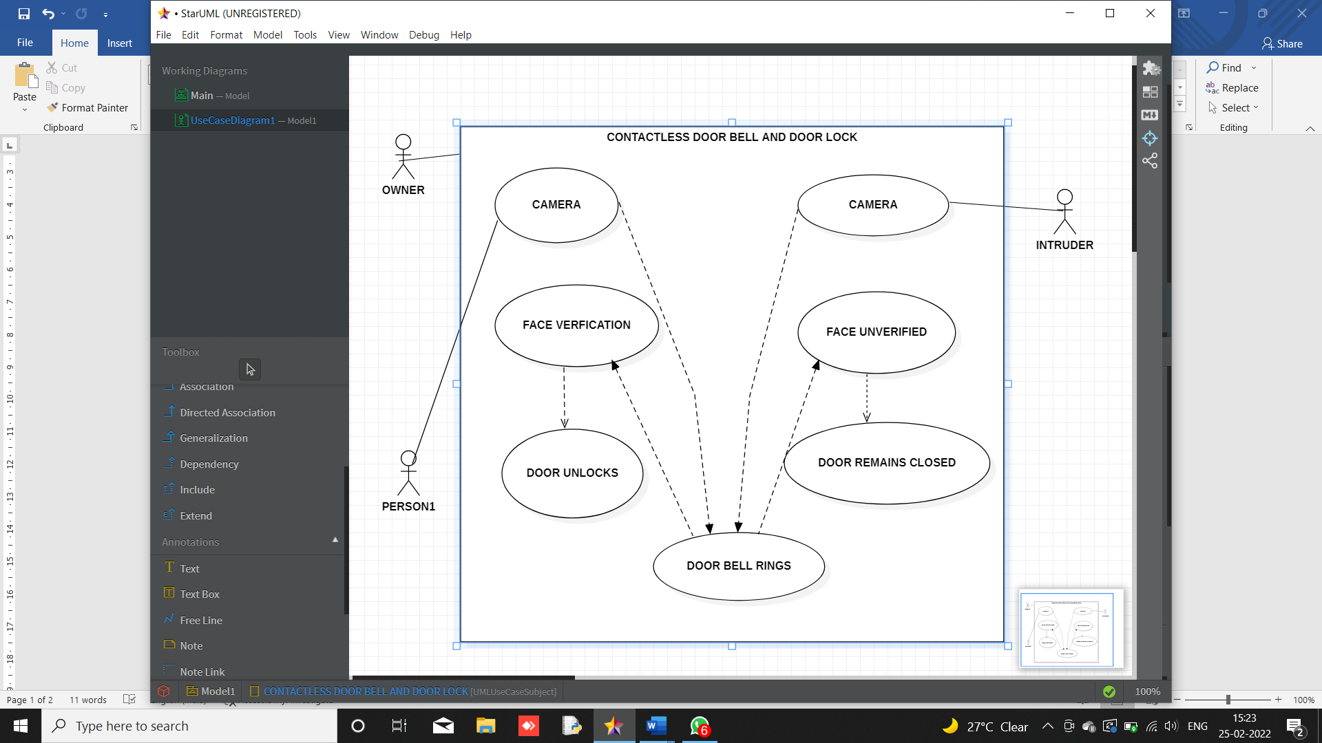

Figure 2

#### 3.2.1 Experimental Figure

When show our hand infront of IR Sensor, The sensor will send signal to Arduino board. And Arduino drive the relay. Relay is connected with doorbell. And finally the bell will ring.

Before starting we need to know about the IR Sensor module.

IR Sensor module is IR based proximity sensor. Mainly it consists of an IR LED Photodiode ,Variable resistor.

Pin Out-

There are three pins in this sensor module .

Vcc- Power supply input (5V)

GND- Power Supply ground

OUT- Output pin(active HIGH)

#### 3.3 Modules The application implementation consists of three modules

Module 1

Designing and implementation of touchless bell.

Module 2:

Designing and implementation of Doorlock system.

Module 3:

Combining Module 1 and Module 2.

**CHAPTER 05 : ADVANTAGES AND DISADVANTAGES**

**ADVANTAGES**

The advantage of using RF Transmitter – Receiver based Wireless Doorbell is that it is very easy to design the circuit and implement.

• The range of the transmission is fairly large. Hence, it is suitable for large homes.

• Another advantage over Bluetooth based data transmission is it doesn’t require any smart phone or Bluetooth enabled phone or any other Bluetooth device.

• In case the system is implemented using a Wi-Fi network, we need to make sure that both the transmitter and receiver are connected to the Wi-Fi network.

• Another wireless technology which can be used for Wireless Doorbell is IR. But the problem is that its range is less and also it is a Line of Sight Communication.

• It has different penetration through the walls of the buildings or houses based on the frequency. Hence used for radio and television transmission and for cellular mobile phone service.

• ➨Used in various medical applications.

• It is used in Diathermy instrument for surgery.

• It is used in MRI for taking images of human body.

• It is also used for skin tightening.

• It is used in radar for object detection.

• It is used for satellite communication.

• It is used in microwave line of sight communication system.

**DISADVANTAGES**

➨Uncontrolled radiation of RF affects pre-adolescent childrens, pregnant women, elderly humans, patients with pace makers, small birds, flora and fauna, small insects etc.

➨The areas near RF cellular towers have been observed with more lightening compare to other areas.

• It also affects some of the fruits grown near the RF tower areas.

• As RF waves are available both in LOS and non LOS regions of transmitter, it can be easily intruded by the hackers and crucial personal/official data can be decoded for malicious motives. In order to avoid this situation, radio frequency wave based transmission is used with highly secured algorithms such as AES, WEP, WPA etc. RF signal can also be modulated either using frequency hopping or spread spectrum techniques to avoid this kind of eavesdropping.

• The areas near RF cellular towers have been observed with more lightening compare to other areas.

• It also affects some of the fruits grown near the RF tower areas.

• As RF waves are available both in LOS and non LOS regions of transmitter, it can be easily intruded by the hackers and crucial personal/official data can be decoded for malicious motives.

In order to avoid this situation, radio frequency wave based transmission is used with highly secured algorithms such as AES, WEP, WPA etc.

RF signal can also be modulated either using frequency hopping or spread spectrum techniques to avoid this kind of eavesdropping.

CHAPTER 6: REFERENCES AND BIBLIOGRAPHY

<https://www.electronicshub.org/wireless-door-bell/>

https://www.youtube.com/watch?v=_yiEAXdjJm4 – action

https://circuitdigest.com/microcontroller-projects/wireless-doorbell-using-arduino

**CHAPTER: 07 CONCLUSION**

The designed Touchless Doorbell is detecting a person who is visiting a home without touch. To set variable distance user can adjust is by its own. In general, we have sated the distance of person detection as 15 cm. and we have tested for 10-12 distances in the described range and the result was as per expectations. This product functions automatically when a person comes in range of the sensor of touchless doorbell. We also had taken care that the product should be economically affordable. We can place it anywhere we want and also the installation is pretty simple. The setup of wireless doorbell doesn’t require any internal wiring.

This project is based on designing and implementation of doorbell with sound controlled. Doorbells are a common convenience in homes, giving visitors a way of announcing their presence and preventing residents from missing deliveries or guests. Doorbells are simple pieces of home that let you know a visitor has arrived. They're useful if you are too far from the front door to hear someone knocking and preventing residents from missing deliveries or guests. Doorbells are simple pieces of home equipment that let you know a visitor has arrived. They're useful if you are too far from the front door to hear someone knocking. [18] This product is also compared to already existing models of this kind and it has been found that our product contains some unique features such as its variable distance ranging. Overall, we can say that the product serves its purpose and is comparatively better than its competitors in quality as well as economically beneficial.